Export Certificate from browser.

- Open the page in a browser. And click on the 'View Site Information' icon to the left of the URL.



- Click on 'Connection is secure'.

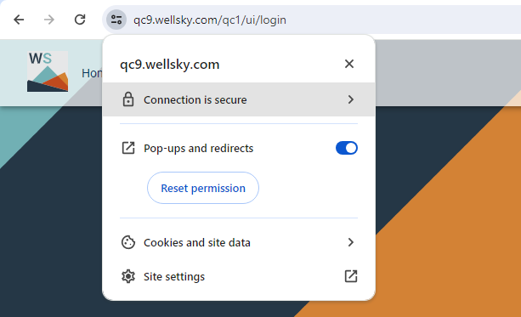

- Click on 'Certificate is valid'.
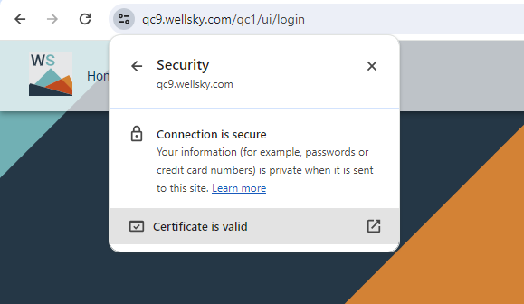

- Goto Details tab and select the root certificate (top level certificate in the available list). This URL had three certificates, so make sure to select the top one (Root) and click 'Export'.

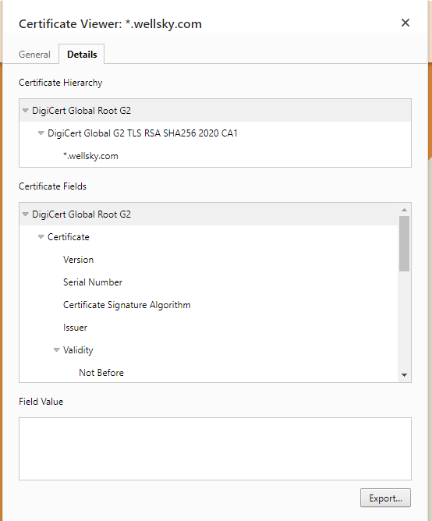

- Save the certificate (.crt)

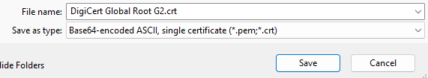

Note: Only root certificate is required for oracle wallet to get the SSL connection to work.

Possible errors and fixes:

1)

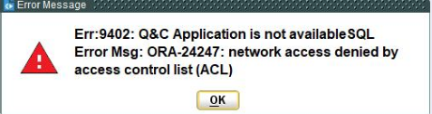

Fix: Provide ACL connection to UTIL and DBADMN users.

2)

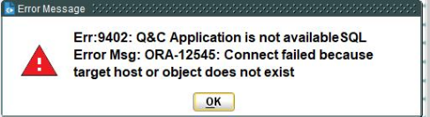

Fix: Linux servers needed manual IP binding with hostname in hosts file

3)

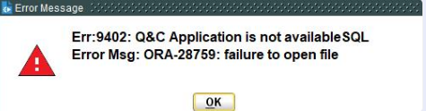

Fix: Restart db after wallet setup.

